פילטר בילטרלי משקלל פיקסלים סמוכים לפי שני גורמים:
- מרחק מרחבי: כמה הפיקסל רחוק מהפיקסל המרכזי.
- הבדל בעוצמת הבהירות: כמה ערך הפיקסל שונה מהפיקסל המרכזי.
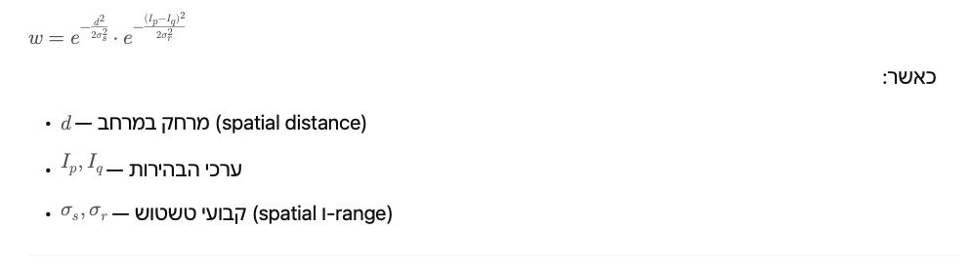
שלבי מימושמימוש פונקציית Gaussian

כתוב את הנוסחה:
np.exp(-distance**2 / (2 * sigma**2))
לולאת עיבוד מרכזית
- עבור על כל פיקסל בתמונה.
- בחר חלון סביבו בגודל
window_size
.
- לכל שכן:
  - חשב מרחק מרחבי (dx, dy).
  - חשב הבדל עוצמה (|I_center - I_neighbor| ).
  - חשב משקל מרחבי ומשקל עוצמה.
  - כפל ביניהם לקבלת המשקל הכולל.
  - בצע ממוצע משוקלל לפי משקלים אלו.
נירמול

חלק את הסכום המשוקלל בסכום המשקלים.המרה חזרה ל־uint8

לאחר סיום, חתוך לערכים בין 0–255. בדיקה

#!/usr/bin/env python3
# -*- coding: utf-8 -*-
"""
Bilateral Filter Implementation - Classroom Exercise
Image Processing Course - Spatial Operations
Basic edge-preserving smoothing filter

"""

import numpy as np
import time
from typing import Tuple

# Protection against using forbidden functions
FORBIDDEN_FUNCTIONS = ['bilateralFilter', 'edgePreservingFilter', 'jointBilateralFilter']

def check_forbidden_imports():
"""Check that no forbidden OpenCV functions are being used"""
import inspect
frame = inspect.currentframe()
if frame and frame.f_globals:
for forbidden in FORBIDDEN_FUNCTIONS:
if forbidden in str(frame.f_globals):
raise ValueError(f"Forbidden function {forbidden} detected! Use not allowed.")

def gaussian_weight(distance: float, sigma: float) -> float:
"""
Calculate Gaussian weight for given distance

Parameters:
-----------
distance : float
Distance value (spatial or intensity)
sigma : float
Standard deviation

Returns:
--------
float
Gaussian weight
"""
# TODO: Implement Gaussian weight calculation
# Hint: G(x) = exp(-x^2 / (2 * sigma^2))
pass

def bilateral_filter_basic(image: np.ndarray,
window_size: int = 5,
sigma_spatial: float = 3.0,
sigma_range: float = 50.0) -> np.ndarray:
"""
Basic implementation of bilateral filter

The bilateral filter is an edge-preserving smoothing filter that
combines spatial and intensity-based weighting.

Parameters:
-----------
image : np.ndarray
Input grayscale image (0-255)
window_size : int
Filter window size (must be odd, e.g., 3, 5, 7)
sigma_spatial : float
Spatial standard deviation (controls spatial extent)
sigma_range : float
Range/intensity standard deviation (controls edge preservation)

Returns:
--------
np.ndarray
Filtered image with same size and type as input

Raises:
-------
AssertionError
If parameters are invalid
"""
check_forbidden_imports()

# Input validation
assert window_size % 2 == 1, "Window size must be odd"
assert window_size >= 3, "Minimum window size is 3"
assert sigma_spatial > 0, "Spatial sigma must be positive"
assert sigma_range > 0, "Range sigma must be positive"
assert len(image.shape) == 2, "Input must be grayscale image"

# Convert to float64 to prevent overflow
img = image.astype(np.float64)
output = np.zeros_like(img)

# Image dimensions
height, width = img.shape
half_window = window_size // 2

# TODO: Implement bilateral filter
# Steps:
# 1. For each pixel (i,j) in the image:
# a. Define the neighborhood window
# b. For each neighbor pixel (k,l) in the window:
# - Calculate spatial distance
# - Calculate intensity difference
# - Compute spatial weight using Gaussian
# - Compute range weight using Gaussian
# - Total weight = spatial_weight * range_weight
# c. Normalize weights and compute filtered value

for i in range(height):
for j in range(width):
# TODO: Complete implementation
# Initialize weighted sum and weight sum
weighted_sum = 0.0
weight_sum = 0.0

# Get center pixel value
center_value = img[i, j]

# Process neighborhood
# TODO: Add your code here

# Store filtered value
output[i, j] = weighted_sum / weight_sum if weight_sum > 0 else center_value

return np.clip(output, 0, 255).astype(np.uint8)

def load_image(filename: str) -> np.ndarray:
"""
Load image from file (numpy array or simple formats)

Parameters:
-----------
filename : str
Path to image file

Returns:
--------
np.ndarray
Loaded image
"""
if filename.endswith('.npy'):
return np.load(filename)
else:
# For other formats, try to load as numpy array
try:
return np.loadtxt(filename, dtype=np.uint8)
except:
# Create a dummy image if loading fails
print(f"Warning: Could not load {filename}, using dummy image")
return np.random.randint(0, 256, (100, 100), dtype=np.uint8)

def save_image(image: np.ndarray, filename: str):
"""
Save image to file

Parameters:
-----------
image : np.ndarray
Image to save
filename : str
Output filename
"""
if filename.endswith('.npy'):
np.save(filename, image)
else:
np.savetxt(filename, image, fmt='%d')

def test_basic_implementation():
"""Test function for basic implementation"""
print("Testing basic bilateral filter implementation...")

# Create test image with noise
test_img = np.ones((100, 100), dtype=np.uint8) * 128
test_img[40:60, 40:60] = 200 # Add bright square
noise = np.random.normal(0, 20, test_img.shape)
noisy_img = np.clip(test_img + noise, 0, 255).astype(np.uint8)

# Apply filter
start_time = time.time()
filtered = bilateral_filter_basic(noisy_img)
elapsed = time.time() - start_time

print(f"Filtering completed in {elapsed:.3f} seconds")
print(f"Input range: [{noisy_img.min()}, {noisy_img.max()}]")
print(f"Output range: [{filtered.min()}, {filtered.max()}]")

# Basic validation
assert filtered.shape == noisy_img.shape, "Output shape mismatch"
assert filtered.dtype == np.uint8, "Output type should be uint8"
print("Basic tests passed!")

if __name__ == "__main__":
test_basic_implementation()

